**Challenge Exercise #1:** complete the following program using a function

**#1 print screen the output with code below here.**

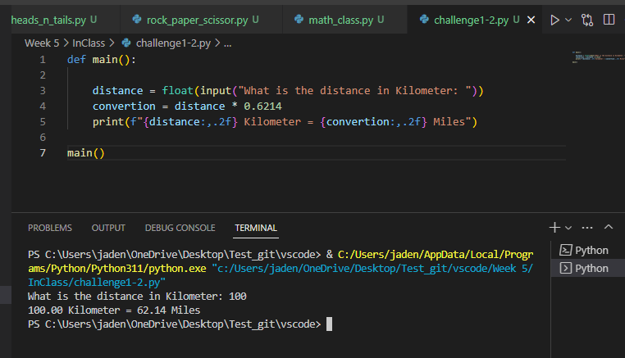

**Challenge Exercise #2:** complete the following program using a function

**#2 print screen the output with code below here.**

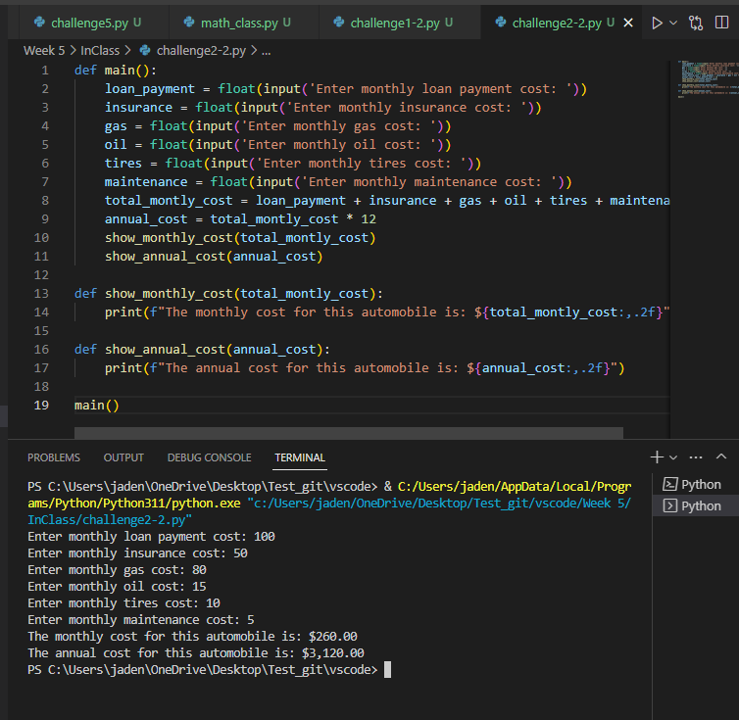

**Submit this document to Module 5 Class Exercise.**